Name: ………………………………………. Class:……………………………

​​Y7 RE KNOWLEDGE ORGANISER HOMEWORK SPRING 1 ​

Unit 3: Judaism
L1: The Torah
L2: The Tanakh (Prophecies)
L3: The Tanakh (The Writings)
L4: The Talmud
L5: Daily and weekly practices: Prayer and Shabbat
L6: Community practices: The Synagogue
L7: Annual practices: Pesach
L8: Once in a lifetime practices: Bat and Bar Mitzvot
L9: Tikkun Olam

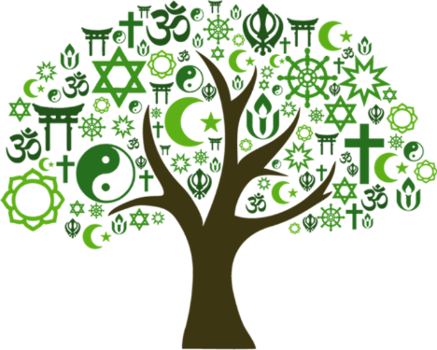

L1: The Torah

- Who was Abraham? | The founder of Judaism and husband of Sara.
- What is a Covenant? | An agreement between two sides (between humans and God).
- Who was Sara? | Female leader, mother of nations and wife of Abraham.
- Who was Isaac? | The son of Abraham and Sara.
- Food which is prepared, cooked and eaten according to Jewish food laws is called… | Kosher
- The First Book in the Torah is called… | Genesis
L2: The Tanakh (Prophecies)

- What is the collection of books in the Tanakh which are written about prophets called? | Nevi’im
- A message given to humans from God, usually to a prophet is called… | Prophecy
- Being forced to leave your country or home and live somewhere else | Exiled
- What is the name of the Hebrew Bible, which includes the Torah, Nevi’im and Ketuvim? | Tanakh
- Has the number of non-religious people increased or decreased? | Increased
L3: The Tanakh (the writings)

- ​What is name of the collection of different types of writing in the Tanakh. | Ketuvim
- Taking the meaning of the words exactly as they seem to be is known as… | Literal
- Taking the meaning of the words as representing other things is known as… | Symbolic
- The Ketuvim contains what three types of writing? | poetry, Historical narratives and Advice
- Who was the important person mentioned in the Ketuvim | Esther
L4: The Talmud

- A particular religious group which has some different beliefs from other groups within the same faith is known as… | Denominations
- Which denomination believes that the Torah is the words of Moses inspired by God? | Reform
- Which denominations believes that The Talmud is the Oral Torah given to humans by God? | Orthodox
- What word ‘law’ mean in Hebrew? | Torah
- What contains discussions and interpretations of the Torah which guides Jewish law and practice? | Talmud
L5: Daily and weekly practices: prayer and Shabbat

- What is an act of communication between humans and God? | Prayer
- How did God first appear to Moses? | in a burning bush
- What was the final plague? | The death of the first born sons in Egypt
- Who was Miriam? | Moses' sister
- Which of Abraham's sons was Moses a descendant of? | Isaac
L6: Community practices: the synagogue

- What language was the Torah written in? | Hebrew
- What is the name of a small black leather boxes containing parts of the Torah worn on the head and arms.? | Tefillin
- What is the name of the prayer that reminds Jewish people of the monotheism of their faith? | Shema
- What is the name of the "standing prayer" which involves praising God, asking God for help and thanking God? | Amidah
- A day of rest and worship observed from Friday evening to Saturday evening is called… | Shabbat
L7: Annual practices: Pesach

- Pesach commemorates (remembers) which story? | Exodus story
- What is the Jewish word for ‘order’? | Seder
- What represents the bitterness of lives lived in enslavement in Egypt.? | Bitter herbs
- What is the Matzah? | Unleavened bread
- What "passed over" the Egyptians homes during the final plague? | Angel of death
L8: Once in a lifetime practices: Bat and Bar Mitzvah

- What are special ceremonies which mark someone’s ​passage through life called? | Rites of passage
- What are the two denominations in Judaism? | Reform and Orthodox
- What is the name of the Jewish coming-of-age ceremony for only girls? | Bat Mitzvah
- What is the name of the Jewish coming-of-age ceremony for boys and girls? | Bar Mitzvah
- What language will a young person read aloud in during the ceremony? | Hebrew
L9: Tikkun Olam
- What does the word ‘tikkun olam’ mean? | Repair the world
- What is the first book of the Torah? | Genesis
- What are three dangers the earth is facing? | Climate change, deforestation, pollution
- Who in the USA are using sustainable farming techniques? | Tikkun farm.
- What Jewish group is linked to environmental awareness? | Eco Judaism

